Git and GitHub notes by pulkitdubey046
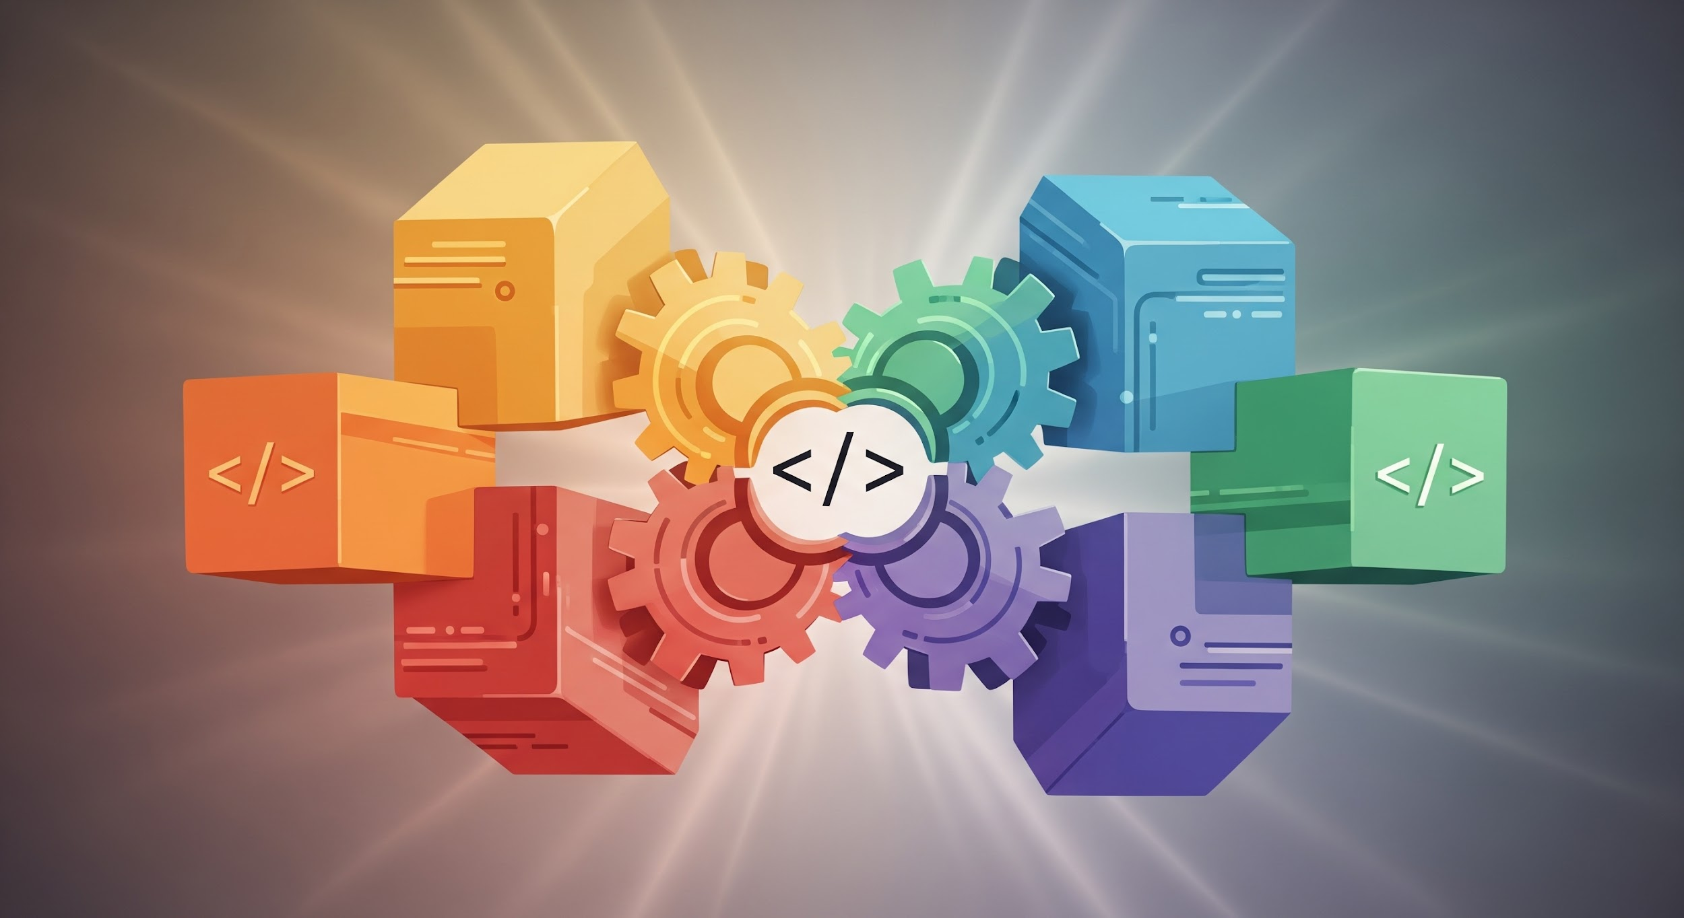

Welcome to Git and GitHub!
Hello! If you're starting your coding journey, you've probably heard of Git and GitHub. They are essential tools for every software developer, and learning them is much easier than you might think. This guide will take you step-by-step, assuming you know absolutely nothing about them.

We're going to keep things simple, safe, and friendly!

Part 1: Understanding Git (The Tool)

1. What is Version Control?
Imagine you are writing a very important paper. Every time you make big changes, you save a new copy:

- Paper_Draft_1.docx
- Paper_Draft_2_After_Review.docx
- Paper_Final_Final_V3.docx

This quickly becomes messy!

Version Control is a system that automatically keeps track of every single change you make to your code or documents over time.

- It's like an unlimited "undo" button that works for the entire project.
- You can instantly travel back in time to any previous state of your project.
- It is fantastic for teamwork, allowing multiple people to work on the same files without overwriting each other's work.

2. What is Git?
Git is the most popular type of Version Control System (VCS).

Think of Git as a powerful, digital time machine installed on your computer. It watches your project files and carefully records changes when you tell it to.

Why do we use Git?

- Safety: Never lose your work. You can always recover old versions.
- Tracking: Know who changed what, when, and why.
- Collaboration: Essential for working with other developers.

3. Key Concepts in Git
Before using commands, let's understand the main terms:

Repository (Repo)
A Repository is just a fancy name for your project folder, but with a special .git subfolder hidden inside. This .git folder is where Git stores all of its history, tracking data, and "time machine" files.

Concept | Simple Analogy
Repository | The entire project folder being tracked.

Commit
A Commit is a snapshot of your project at a specific point in time. It is the basic unit of history in Git.

When you make a commit, you are essentially telling the Git time machine: "Save the project exactly as it is right now, and remember I did this."

Concept | Simple Analogy
Commit | Taking a snapshot and writing a note about why you took it.

Staging Area
The Staging Area (sometimes called the "Index") is a middle ground between your working files and a commit.

Think of it as a waiting room for changes. You use the Staging Area to select exactly which changes you want to include in your next snapshot (commit).

Concept | Simple Analogy
Staging Area | Picking and preparing the exact files you want in the next snapshot.

Branch
A Branch is a separate line of development.

Imagine the main version of your project is the "trunk" of a tree. When you start a new feature, you create a new branch (a separate line) off the main trunk. You can make all the messy, experimental changes you want on your branch without affecting the stable, working main project.

Concept | Simple Analogy
Branch | A separate, safe workspace to build a new feature or fix a bug.

Part 2: Git Setup and First Steps

1. Installing Git
Git is usually installed through your operating system's package manager or an installer.

To check if it's installed, open your terminal (on Mac/Linux) or Command Prompt/Git Bash (on Windows) and type:git --version

If it shows a version number (like git version 2.43.0), you're ready!

2. Setting Up Your Identity
Git needs to know who you are so it can label your commits correctly. This is one-time setup:git config --global user.name "Your Name"

git config --global user.email "your.email@example.com"

3. Creating Your First Repository
We will start tracking a new project.

Step 1: Create a new folder for your project and navigate into it using your terminal.mkdir my-first-git-project

cd my-first-git-project

Step 2: Tell Git to start tracking this folder. This creates the hidden .git folder.git init

This command is safe and only needs to be run once per project.

4. The Daily Git Workflow (Local)

A. Checking the Status
The git status command is your best friend. It tells you exactly what Git is seeing.git status

git status output | Meaning
Untracked files | New files Git doesn't know about yet.
Changes not staged for commit | Files Git knows about, but your latest changes haven't been selected for the snapshot.
Changes to be committed | Files that are in the Staging Area, ready for the next commit.

B. Adding Files (Staging)
Let's create a file (README.txt) and add some content.

To move the changes from your working directory into the Staging Area, use git add.git add README.txt

If you want to stage ALL changed files at once (be careful with this!), you can use:git add .

Run git status again to see the file is now green (ready to be committed).

C. Committing (Taking the Snapshot)
Now that the file is staged, we take the snapshot (the commit). You must include a short, meaningful message explaining the changes.git commit -m "Initial commit: Added the project README file"

The -m stands for "message." Your message should clearly summarize why you made these changes.

Congratulations! You just made your first Git commit.

5. Viewing History
To see a list of all the commits (snapshots) you've made, use git log.git log

This will show who made the commit, when, and the commit message.

6. Branching (Your Safe Workspace)
The default branch is usually named main or master. It's the stable version. Let's create a new branch to work on a feature.

Step 1: Create a new branchgit branch feature-login

Step 2: Switch to the new branchgit checkout feature-login

Now, any changes you make and commit will only exist on the feature-login branch. The main branch remains untouched and stable.

Merging (Bringing Changes Back)
When your feature is complete and tested, you merge your branch back into the stable main branch.

Step 1: Switch back to the stable branchgit checkout main

Step 2: Merge the feature branch into the stable branchgit merge feature-login

Git will combine the history and file changes. If all goes well, your new feature is now part of the main branch!

7. Undoing Common Mistakes Safely

Mistake 1: I Staged the Wrong File
You ran git add . but accidentally staged a file you didn't mean to.

Solution: Unstage the filegit restore --staged <file-name>

Mistake 2: I Made Changes I Don't Want (Before Commit)
You were editing a file, but now you realize those changes were a bad idea and you want to revert to the last committed version.

Solution: Discard local changesgit restore <file-name>

Part 3: GitHub (The Platform)

1. What is GitHub?
If Git is your personal time machine (a tool on your computer), GitHub is a massive, shared time-machine library on the internet.

- GitHub is a company that provides a service based on Git.
- It's a hosting service for Git repositories.
- It's the world's largest platform for software development collaboration.

2. Why Do We Need GitHub?
- Backup: If your computer breaks, your code is safely stored online.
- Collaboration: It allows your teammates (or anyone in the world) to see, download, and contribute to your code.
- Showcase: It acts as a professional portfolio for software engineers.

3. Connecting Local Git to GitHub

A. Creating a GitHub Repository
- Go to the GitHub website and log in.
- Click the "New" button to create a new repository.
- Give it a name (e.g., my-first-git-project).
- Do NOT check the box to initialize with a README (since you already have a local one).
- Click "Create repository."

GitHub will provide you with a unique link (URL) to your new remote repository.

B. Linking Local to Remote
In your local project folder (my-first-git-project), you need to tell Git the address of your GitHub repository.git remote add origin <GitHub URL provided>

- remote add: Tell Git you're adding a remote server.
- origin: This is the nickname we give to that remote server (it's the standard default name).

C. Sending Your Code Online (git push)
The git push command is how you upload your local commits (snapshots) from your computer to the GitHub server.

The first time you push, you need to set the upstream branch:git push -u origin main

After the first time, you can usually just type:git push

Your code and commit history are now safely on GitHub!

D. Getting Code Changes (git pull)
When working in a team (or switching computers), someone else might have pushed new commits to GitHub. The git pull command downloads any new commits from the remote repository to your local repository.git pull origin main

It is a good habit to run git pull before you start working each day.

4. Basic Collaboration Idea
In a team setting, the workflow involves these steps:

- Pull: Start the day by running git pull to get the latest code from teammates.
- Branch: Create a new feature branch (git checkout -b new-feature).
- Code/Commit: Do your work, stage changes (git add .), and commit (git commit -m "...").
- Push: Push your feature branch to GitHub (git push).
- Merge: Once approved, your feature branch is merged into the main branch on GitHub.
- Pull: Everyone else runs git pull to get the merged changes.

5. Beginner Best Practices & Tips
Tip | Why it matters
Commit Often | Small commits are easier to undo and track than one gigantic commit.
Write Good Commit Messages | The message is the why. It saves you time later when you look back at history.
Use Branches | Always create a branch for new features or fixes. Never work directly on main for major changes.
Run git status often | It tells you exactly what is happening and prevents staging the wrong files.

6. Common Beginner Mistakes with GitHub
- Mistake: Forgetting to run git pull before starting work.
  - Result: You'll write code based on an old version, leading to conflicts when you git push.
- Mistake: Creating two separate repos (one local, one on GitHub) with a README in both.
  - Result: Git gets confused about which main branch to follow.
  - Fix: When creating the GitHub repo, always choose the "Don't initialize with a README" option if you already have a local project.

Summary and Next Steps
You have learned the fundamental concepts and commands for Git and GitHub!

Tool | Role | Commands
Git | The local time machine (version control software). | git init, git add, git commit, git status, git log, git checkout, git merge
GitHub | The online hosting and collaboration platform. | git remote add, git push, git pull

